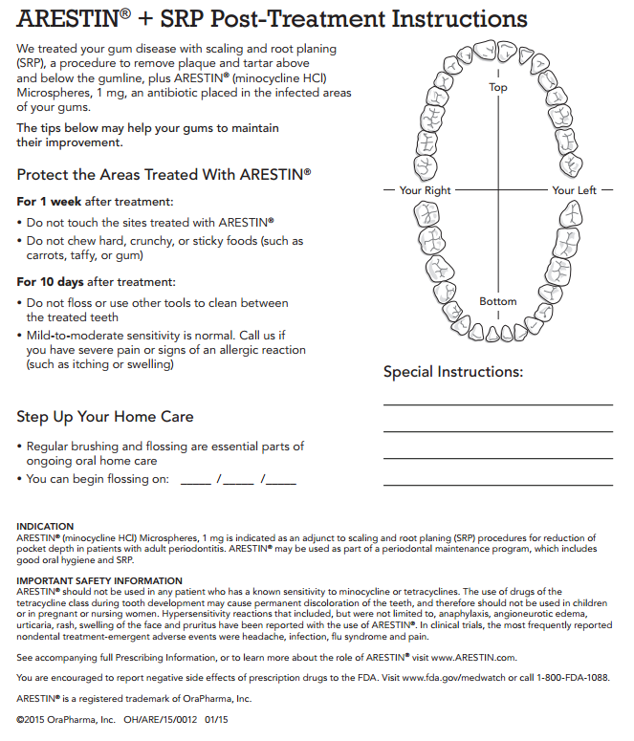
DO NOT BRUSH, FLOSS OR RINSE FOR 12 HOURS AFTER PLACEMENT!

